at

* It is used to schedule job/task that will run only one time.

Command: at -q <priority/queue> <TIMESPEC>

* at provides priority/queue jobs up to 26 queue (a to z). lowest alphabet (a) denotes highest priority and highest alphabet (z) denotes lowest priority.
* Mentioning priority/queue is not mandatory.
* Example:

at now +5min

at teatime tomorrow

at noon +4 days

at 4 AM January 12 2018

* Here, teatime is 4 PM.
* To view scheduled jobs,

Command: atq OR at -l

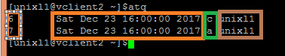

* Here, 1st column: job number; 2nd column: timestamp ; 3rd column: priority/queue; 4th column: owner
* To view scheduled commands run in job,

Command: at -c <job number>

Example: at -c 6

* To remove job,

Command: atrm <job number>

Example: atrm 6